**Project Name:**

Electric fly zapper using voltage multipler.

**Obstruct:**

In this project, we will observe how a half-wave voltage multiplier work and how we can use it in our daily necessary component.

**Advantages of voltage multiplier:**

There is a lot of advantages of voltage multiplier. Such as

* Most common circuit
* Very versatile
* Uniform stress per stage on diodes & capacitors.
* Wide range of multiplication stages.
* Low cost

**Application of voltage multiplier:**

Originally used for television CRT's, voltage multipliers are now used for lasers, x-ray systems, traveling wave tubes (TWT's), photomultiplier tubes, ion pumps, electrostatic systems, copy machines, and many other applications that utilize high voltage DC.

**Necessity of fly zapper:**

None likes bugs at home. To kill these flying insects, they should first be attracted and then electrocuted. An electric fly zapper is one such device with a high voltage electrocuting circuit . To save oneself form harmful insects, it is one of the effective electric device.

**Theory:**

**Voltage Multiplier:**

Voltage multiplier refers to an electrical circuit consisting of diodes and capacitors which multiplies or increases voltage and also converts AC to DC, multiplying of voltage and rectification of current is done using [voltage multiplier](http://www.edgefxkits.com/high-voltage-dc-upto-2kv-from-ac-by-using-diode-and-capacitors-in-voltage-multiplier-circuit). Rectification of current from AC to DC is achieved by diode and increase in voltage is achieved by acceleration of particles by propelling high potential produced by capacitors.

[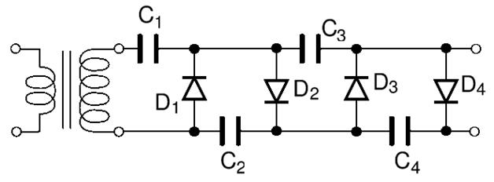](https://www.elprocus.com/wp-content/uploads/2013/09/Voltage-Multiplier.jpg)

Figure (1): Voltage Multiplier

A combination of diode and capacitor makes basic voltage multiplier circuit; AC input is given to circuit from a power source where rectification of current and particle acceleration by capacitor gives an increased voltage DC output. Output voltage can be many times higher to input voltage so load circuit must possess high impedance.

In this voltage doubler circuit the first diode corrects the signal and its output is equivalent to the peak-voltage from the transformer rectified as a half wave rectifier. An AC sign by means of the capacitor additionally achieves the second diode, and in perspective of the DC furnished by the capacitor this makes the output from the second diode sit on top of the first. Along these lines the output from the circuit is double the peak-voltage of the transformer, less the diode drops.

Varieties of circuit and idea are accessible to furnish a voltage multiplier capacity of practically any variable. Applying the same rule of sitting one rectifier on top of an alternate and utilizing capacitive coupling empowers a type of step system to advance.

**Calculation of Output Voltage**

For a voltage multiplier output voltage calculation is important considering voltage regulation and percentage ripple is important.

Vout = (sqrt 2 xVin x N)

Where

Vout = output voltage of N stage voltage multiplier

N = no. of stages (it is no. of capacitor divided by 2)

**Classification of Voltage Multiplier:**

Classification of voltage multiplier is based on ratio of input voltage to output voltage accordingly names also been given as

* Voltage doublers
* Voltage Tripler
* Voltage quadruple

**Fly zapper:**

A bug zapper, more formally called an electrical discharge insect control system, electric insect killer or (insect) electrocutor trap, is a device that attracts and kills flying [insects](https://en.wikipedia.org/wiki/Insect) that are [attracted by light](https://en.wikipedia.org/wiki/Phototaxis).

Bug zappers are usually housed in a protective cage of plastic or grounded metal bars to prevent people or animals from touching the high voltage grid. A light source is fitted inside, often a [fluorescent lamp](https://en.wikipedia.org/wiki/Fluorescent_lamp) designed to emit both [visible](https://en.wikipedia.org/wiki/Visible_spectrum) and [ultraviolet](https://en.wikipedia.org/wiki/Ultraviolet) light, which is visible to insects and attracts them.[[4]](https://en.wikipedia.org/wiki/Bug_zapper#cite_note-4) The light is surrounded by a pair of interleaved bare wire grids or spirals. The distance between adjacent wires is typically about 2 mm (0.079 in). A high-voltage [power supply](https://en.wikipedia.org/wiki/Power_supply) powered by [mains electricity](https://en.wikipedia.org/wiki/Mains_electricity), which may be a simple [transformerless](https://en.wikipedia.org/wiki/Transformer) [voltage multiplier](https://en.wikipedia.org/wiki/Voltage_multiplier) circuit made with [diodes](https://en.wikipedia.org/wiki/Diode) and [capacitors](https://en.wikipedia.org/wiki/Capacitor), generates a voltage of 2,000 [volts](https://en.wikipedia.org/wiki/Volt) or more, high enough to conduct through the body of an insect which bridges the two grids, but not high enough to spark across the air gap. Enough [electric current](https://en.wikipedia.org/wiki/Electric_current) flows through the small body of the insect to heat it to a high temperature.[[5]](https://en.wikipedia.org/wiki/Bug_zapper#cite_note-5) The [impedance](https://en.wikipedia.org/wiki/Electrical_impedance) of the power supply and the arrangement of the grid is such that it cannot drive a dangerous current through the body of a human.

**Equipments:**

1. Breadboard
2. Transformer
3. Ceramic Capacitor
4. Transistor
5. Diode
6. Myler Capacitor
7. Resistor
8. Connection wire
9. Voltage Source

**PIN Configuration of C8850**

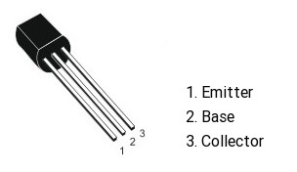

**PIN configuration of S9013**

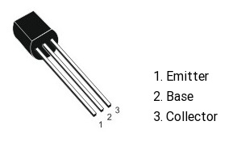

**Circuit Diagram:**

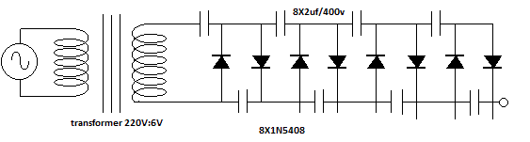

Figure (2): Half-wave voltage multiplier Circuit

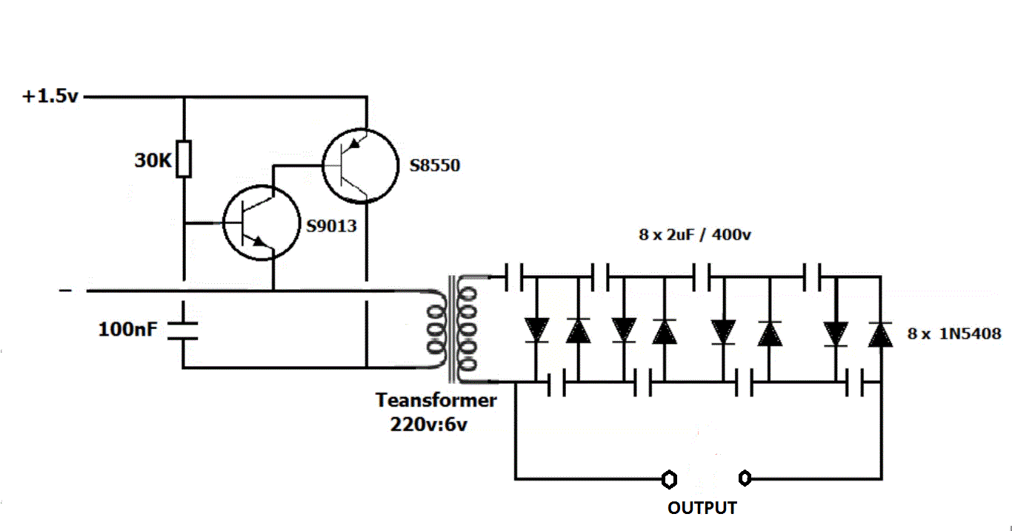 Figure (3): Fly Zapper Circuit

**Procedure:**

**Real Circuit:**

1. **Multiplier:**
2. **Fly Zapper**

**Input and output reading of half-wave multiplier:**

**1)Input: tresing paper(after take measurement)**

**2)output:**

**Doscussion:**

**After circuit done**